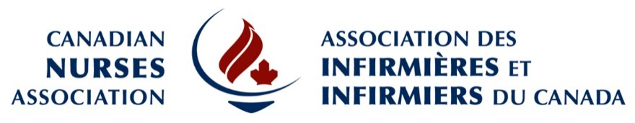

Are you an experienced bilingual communications and media relations professional? Are you interested in contributing to a fast-paced and dynamic team environment to ensure quality and accessible healthcare for all Canadians? If yes, the Canadian Nurses Association (CNA) wants to hear from you!

The Organization:
The Canadian Nurses Association is the national and global professional voice of Canadian nursing, representing over 139,000 registered nurses and nurse practitioners in Canada. CNA advances the practice and profession of nursing to improve health outcomes and strengthen Canada’s publicly funded, not-for-profit health system.
Position: Bilingual Media and Communications Coordinator

Role: This role will develop and execute media relations and communications plans and activities that: engage the media and Canadians on health issues of national concern, promote the nursing profession, and ensure quality and accessible health care for all Canadians. This role will also track media coverage and analyze the effectiveness of PR campaigns, manage the corporate social media platforms and website updates, and coordinate press conferences, editorial boards, and media interviews.

Qualifications:
- University degree in media, journalism, communications, public relations or a related field
- Two to five years of progressive experience in communications, media relations and event coordination
- Experience in implementing standardized project management processes
- Experience in response management during crisis and emergency situations
- Proficiency in media tactics, including interviewing techniques and preparation
- Strong computer skills, particularly in MS Word, Excel, PowerPoint, and InDesign
- Communication, presentation, interpersonal, time management, organizational and problem solving skills
- Fluently bilingual English and French

CNA offers a competitive salary and generous benefits package. For confidential consideration, please forward your application before June 22, 2018 to:

Canadian Nurses Association
c/o Human Resources
50 Driveway
Ottawa, ON K2P 1E2
E-mail: hr@cna-aiic.ca

We thank all applicants however, only those selected for an interview will be contacted.
If you require a disability-related accommodation to participate in the recruitment process, please e-mail us your contact information for follow-up. We will accommodate your needs under the Ontario Human Rights Code.

